# TT Environment KT Document

## Pre-Requisite:

1. List the dates in Ascending order for which date move is required.

## Series of steps for batch run and date move:

Log in to respective server rdp using Login Id and Password provided (same for all)

At start of day, run performance query in SQL.

1. Open rdp for the required server.
2. Check if all duckcreek services are up. (Search services-> open gear icon)
3. Change system date of server
4. Restart IIS
5. Open task Scheduler -> Batch jobs-> latest TT folder-> Run batch1-> Run batch2-> Run batch 3-> batch 4
6. Change date to next date

Restart IIS

Open task Scheduler -> Batch jobs-> latest TT folder-> Run batch1-> Run batch2-> Run batch 3-> batch 4

1. Revert back the system date when done.

Restart IIS.

1. Close

RDP with respective URLS

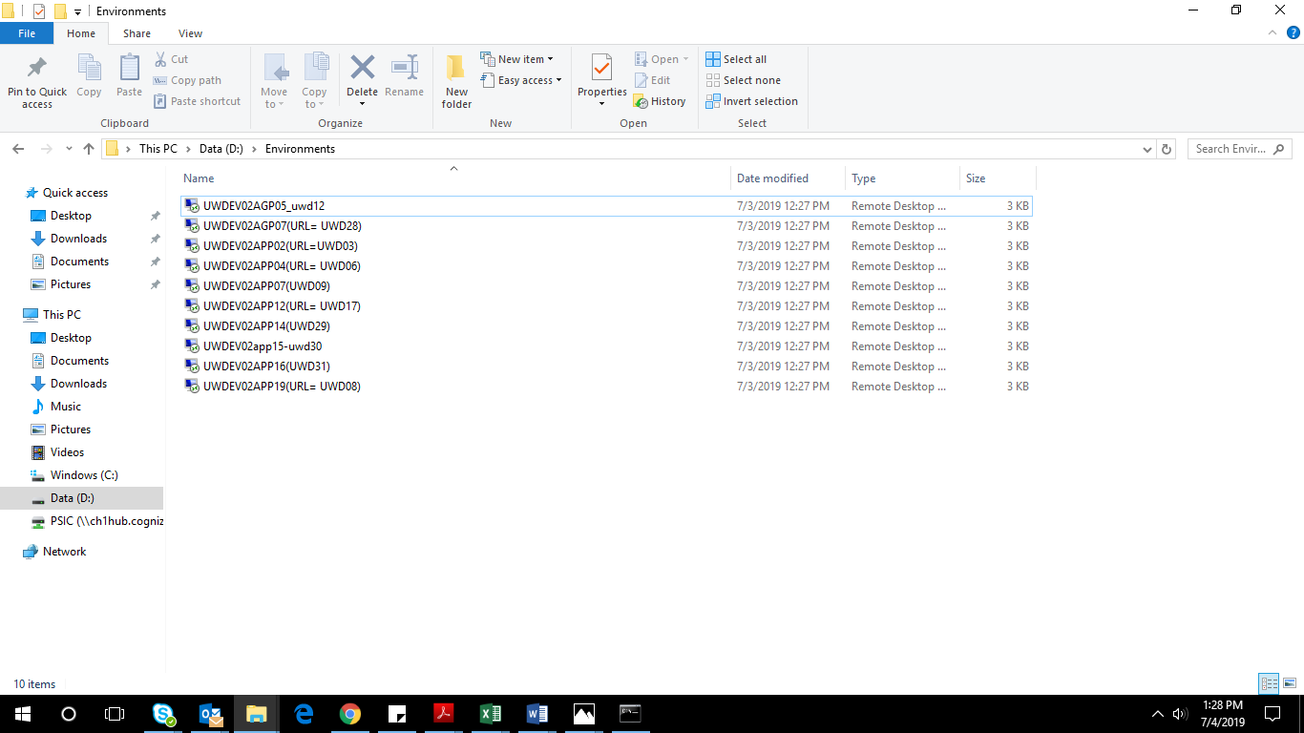

Batches location in RDP:

Open this location when edelivery, FSSI NIIS or other batch run is required. And run the required .bat file

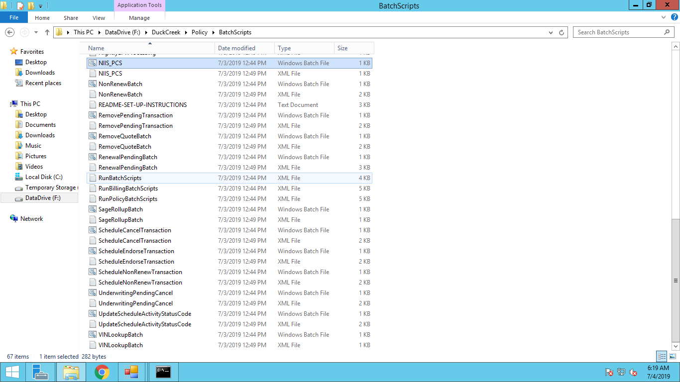

# Steps with Screenshots:

## To check Duckcreek services are running:

Open Start screen by pressing windows key on keyboard

Search services at start screen

Select marked option.

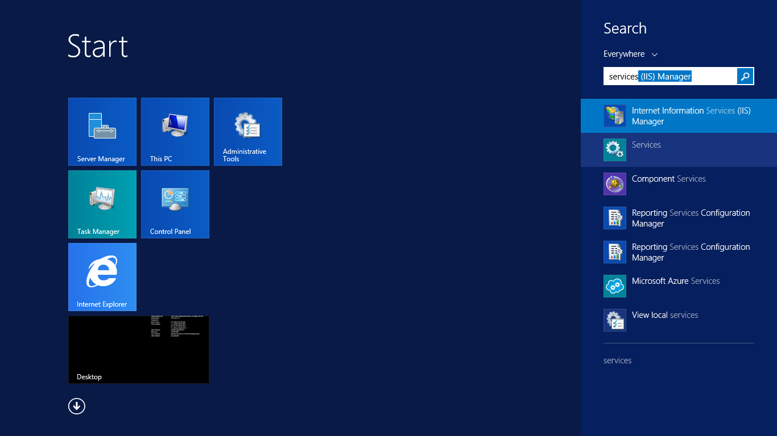

Scroll down -> duckcreek services will be listed:

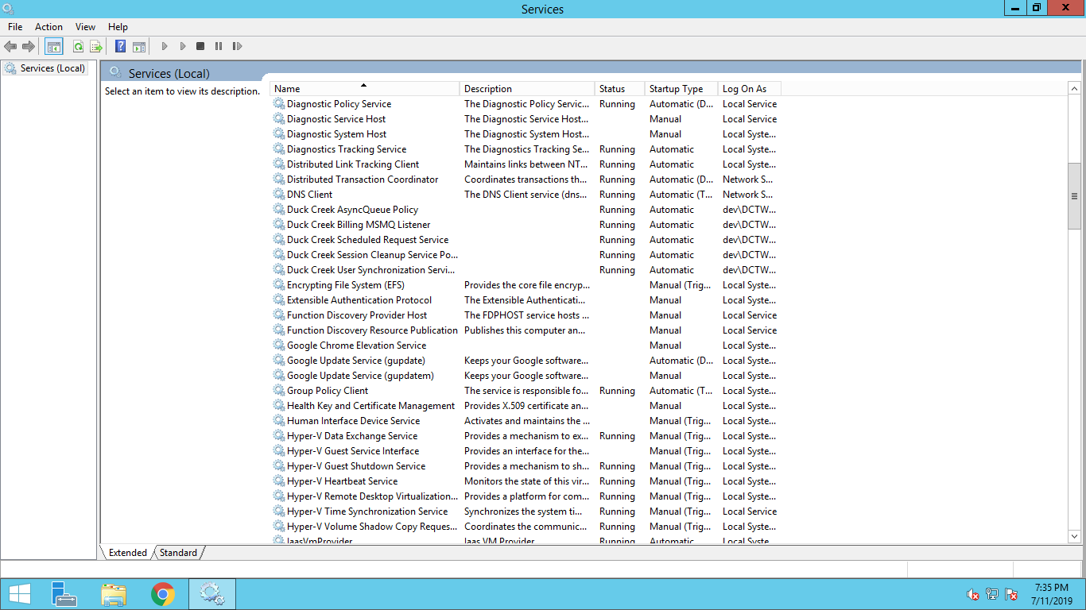

## To Change Date to Required date:

Click on date and time at bottom right corner

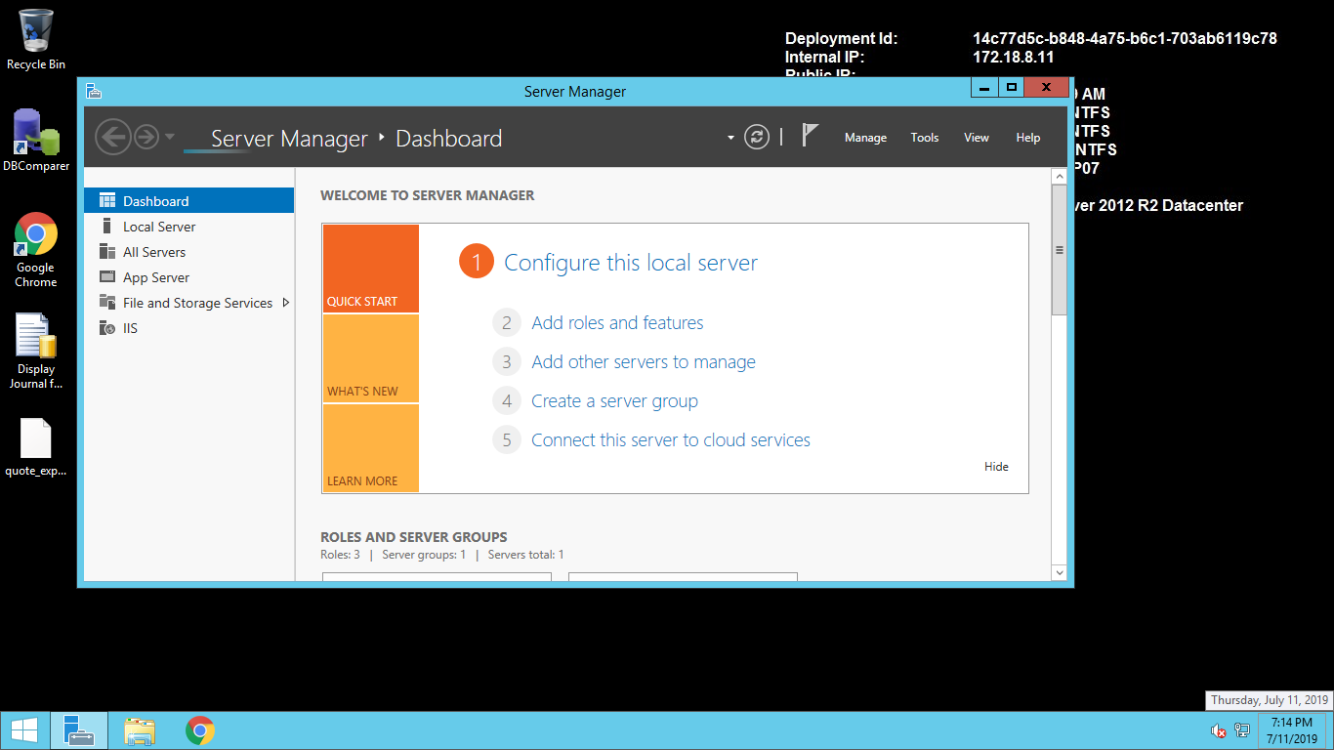

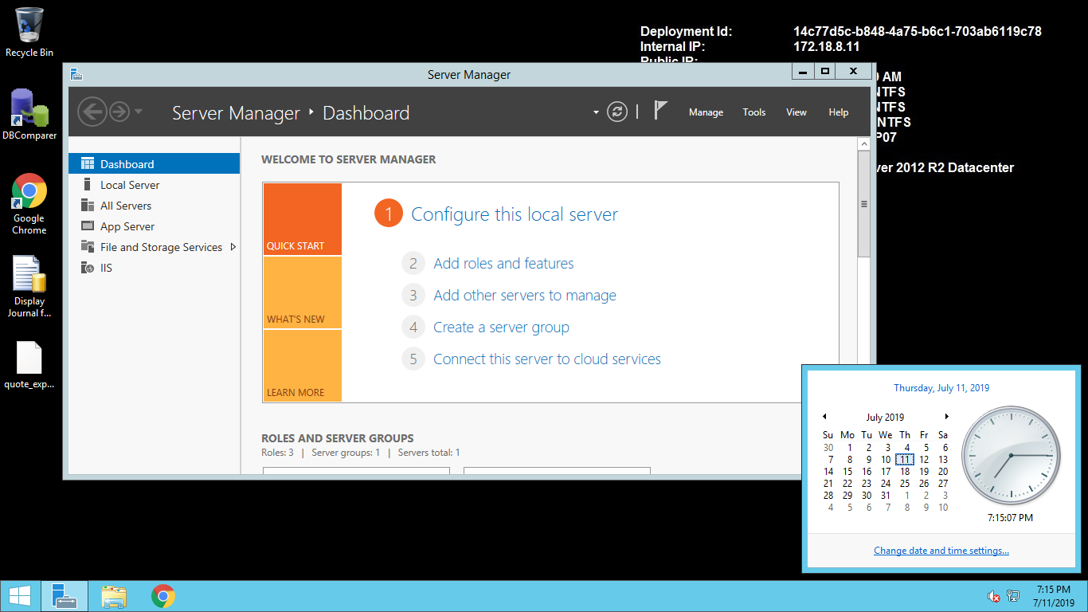

Click on change date and time settings.

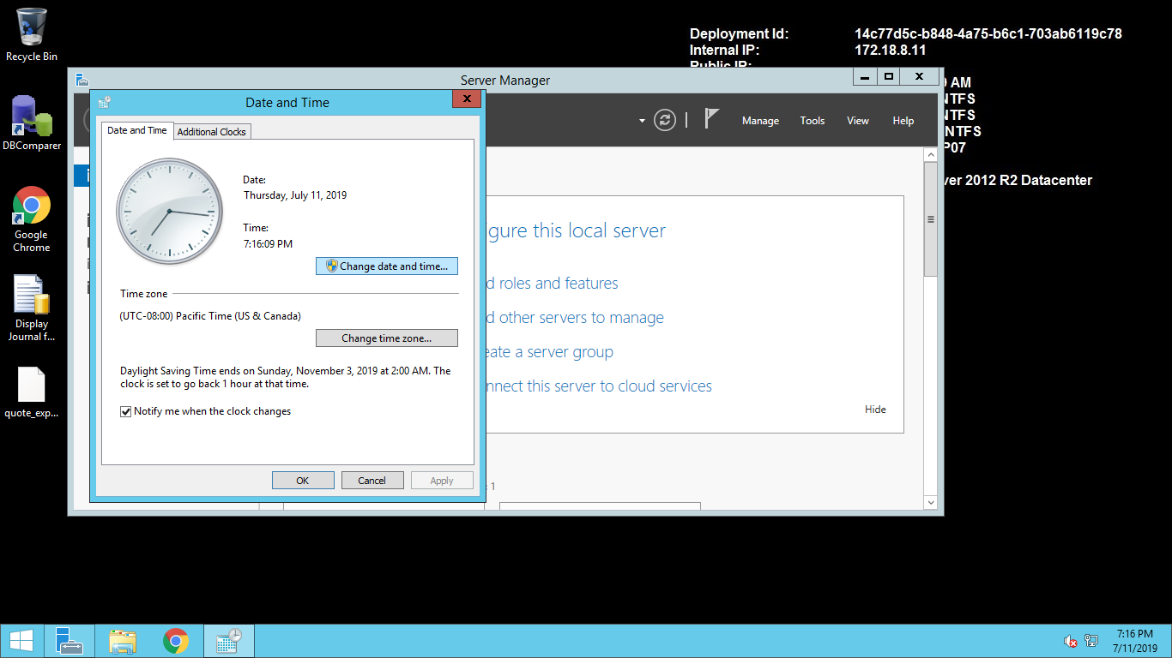

Click on Change date and time … button show above.

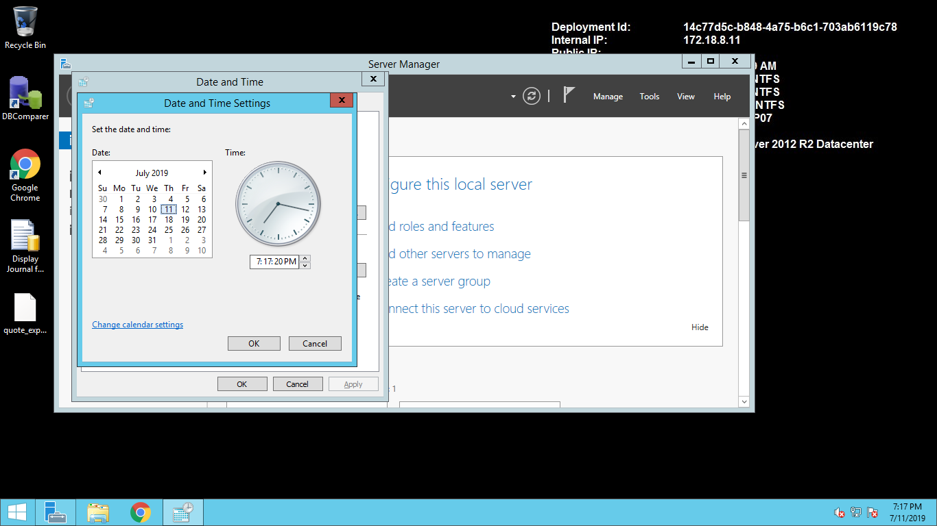

Select required date and click on OK Button.

## After Date is changed Restart IIS :

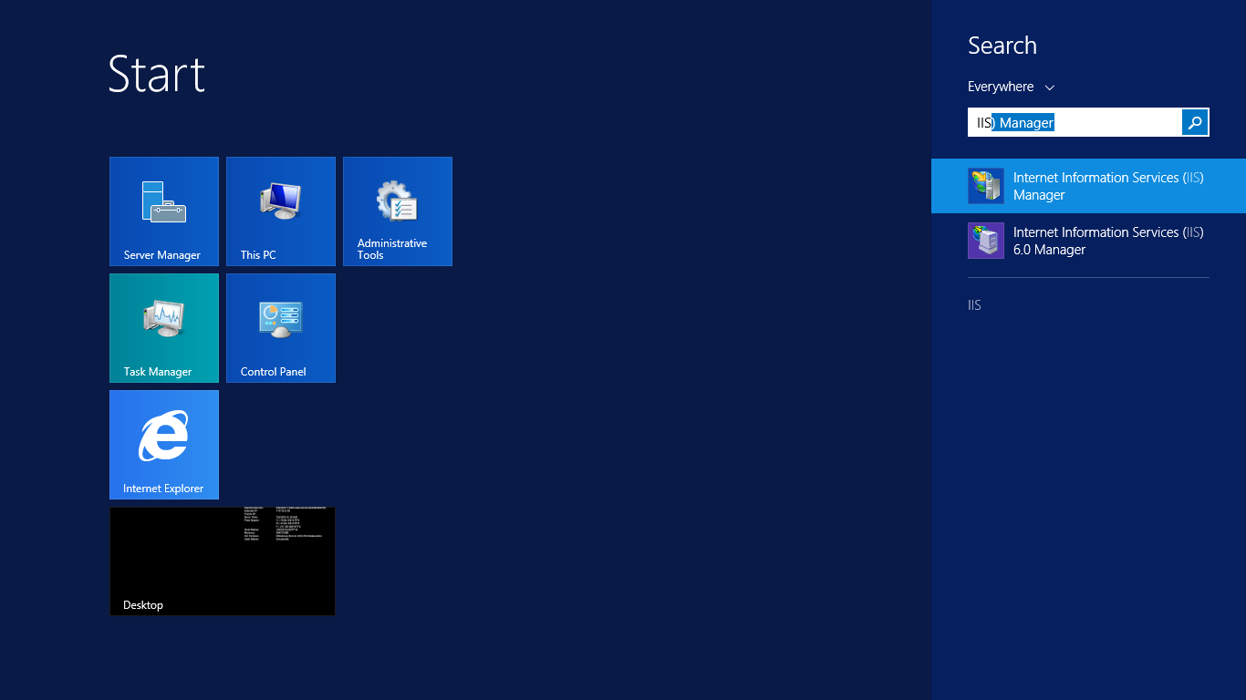

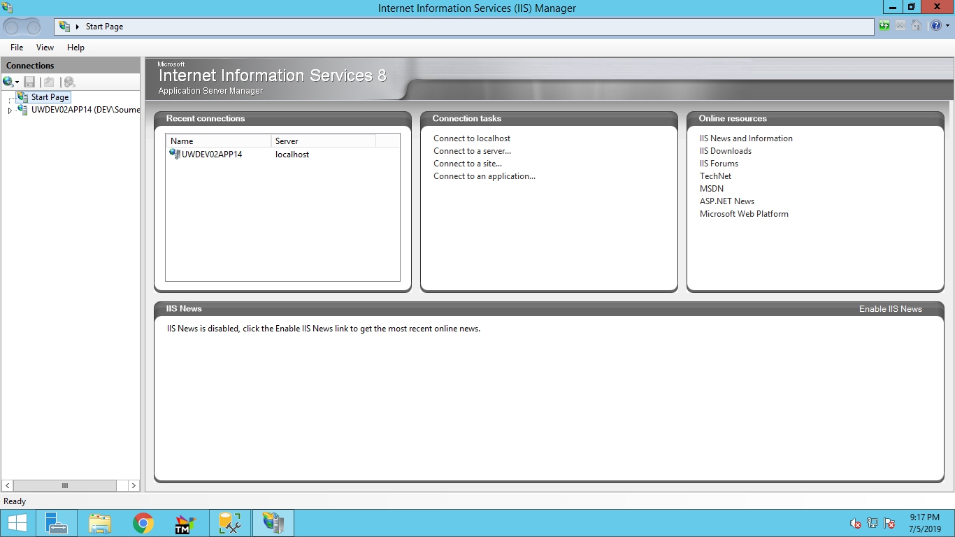

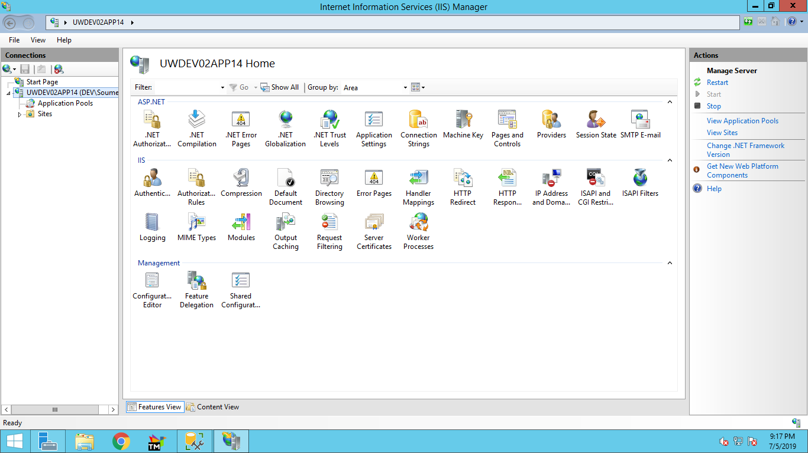

## To Run Batch:

1. Open Task Scheduler

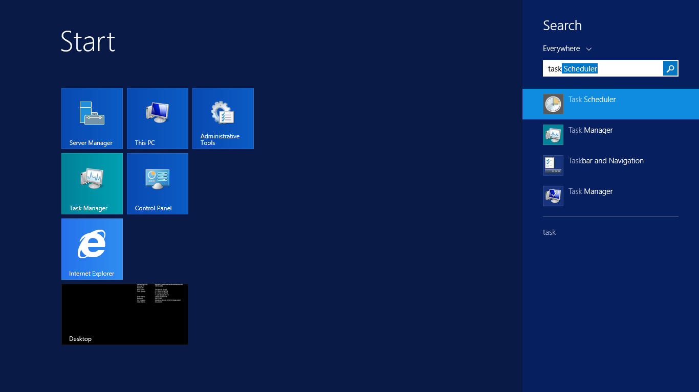

Click on Task Scheduler Library

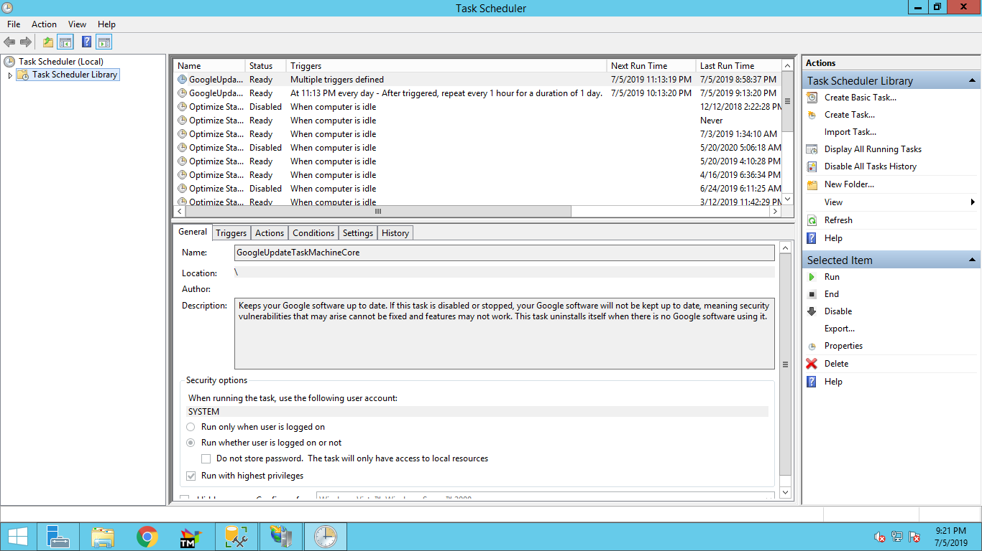

Click on BatchJobs

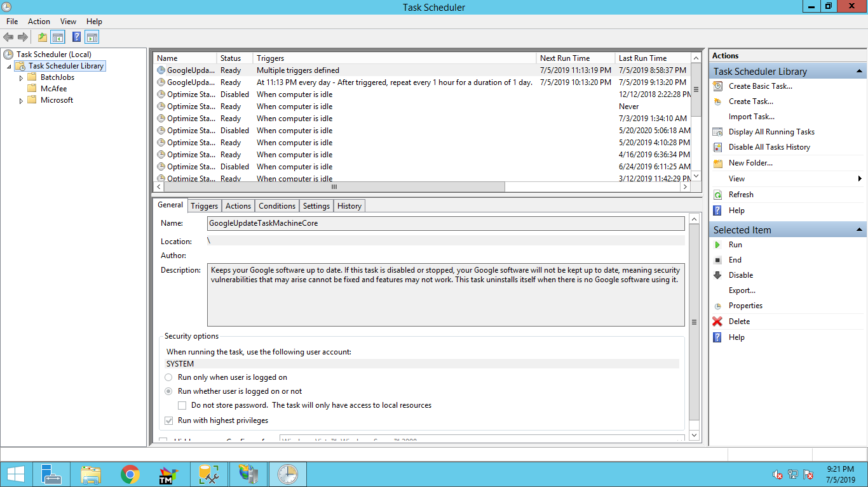

Select latest TT folder

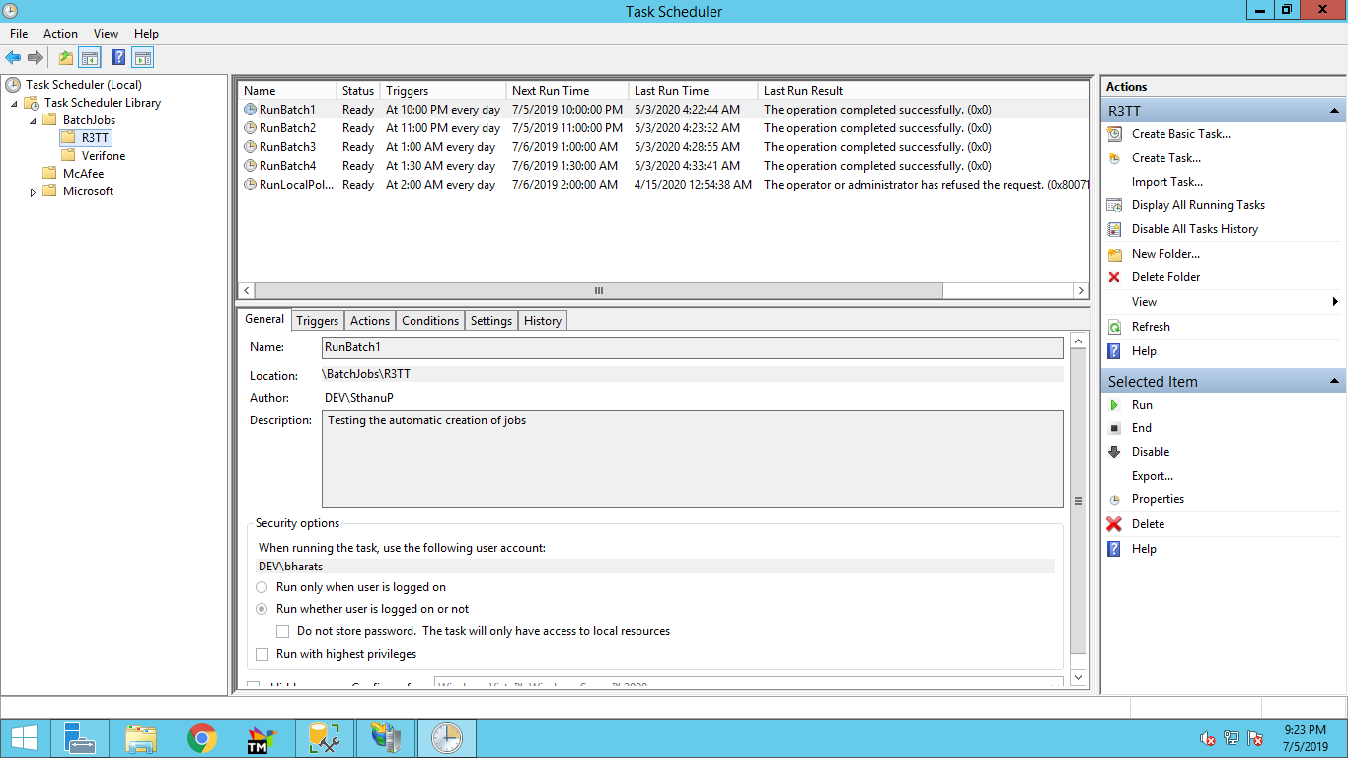

Select RunBatch1 -> Right Click -> click on Run

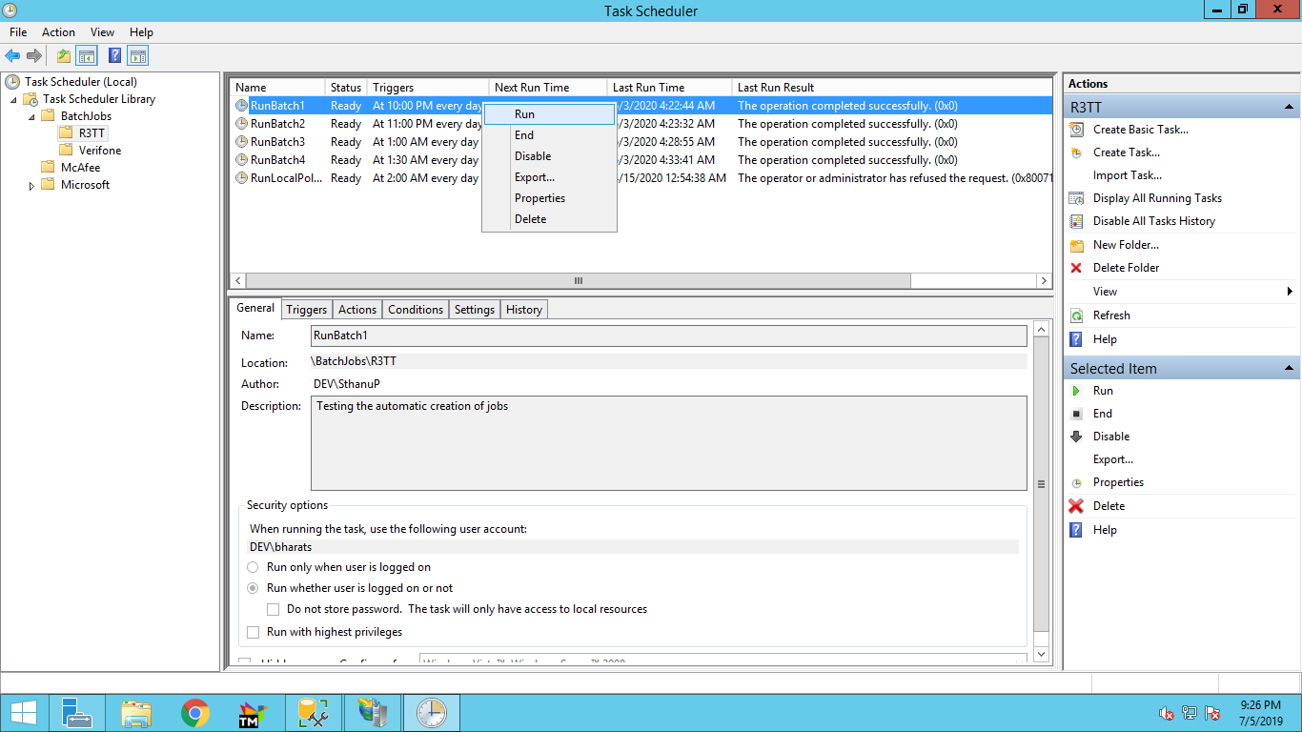

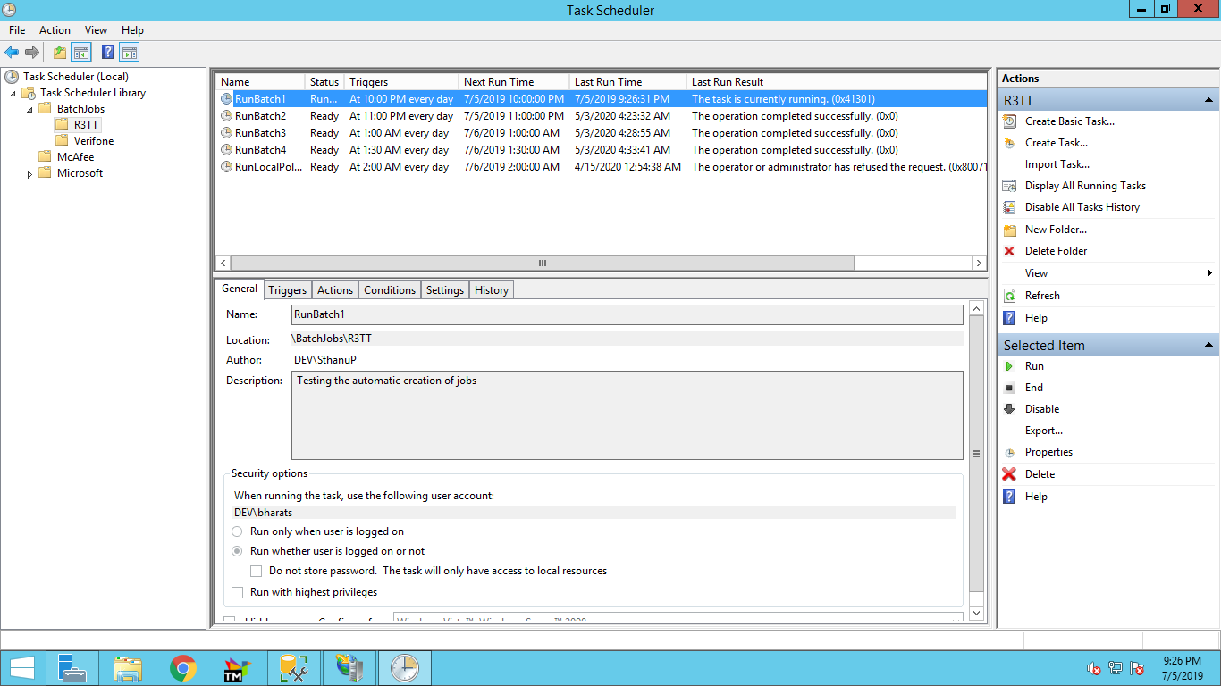

Wait for some time, and right click at space below list of batches and refresh.

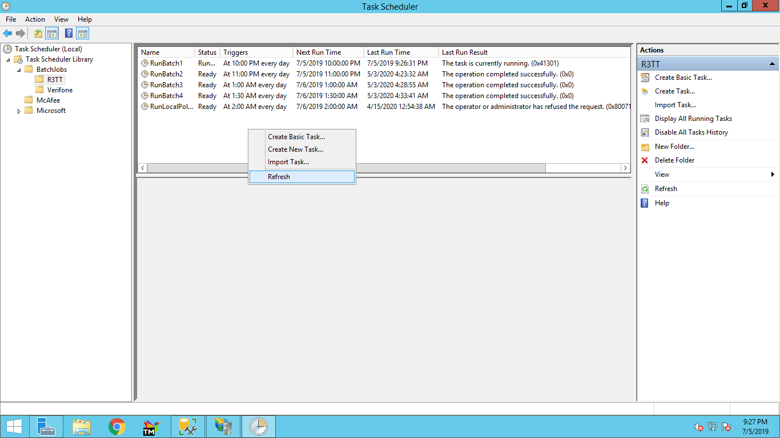

Run next batch when the status of the batch, which was run, is changed back to ready.

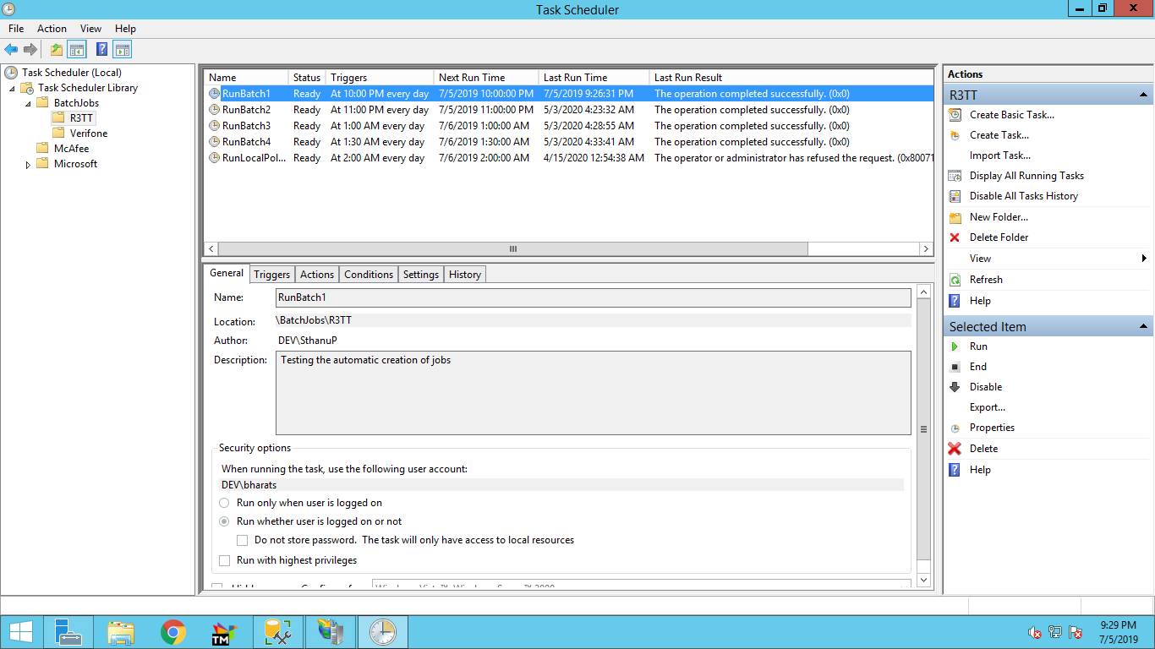

RunBatch1

RunBatch2

RunBatch3

RunBatch4

## To Run Performance query and other sql queries:

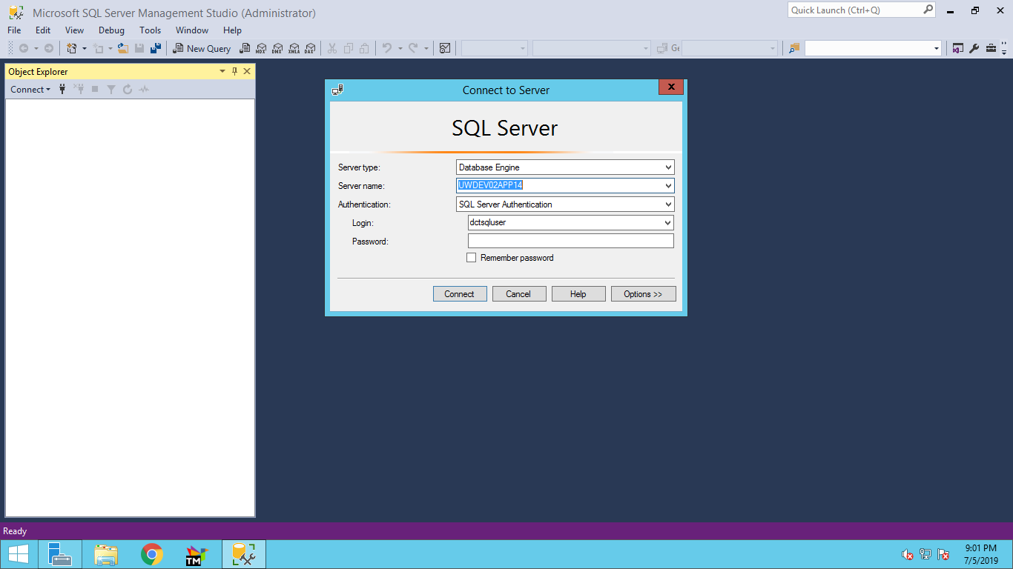

Enter database password:

And connect

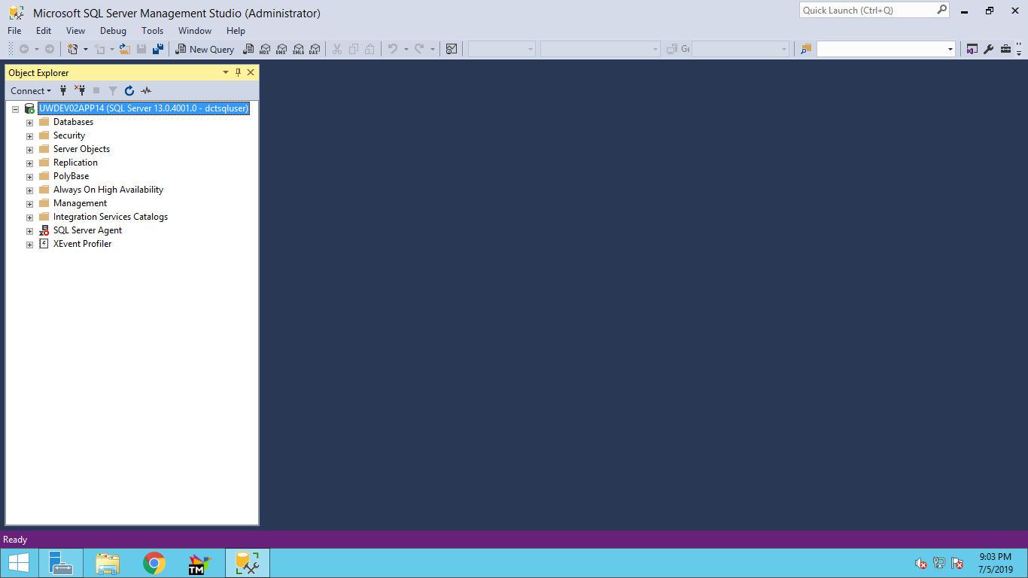

Click on New Query

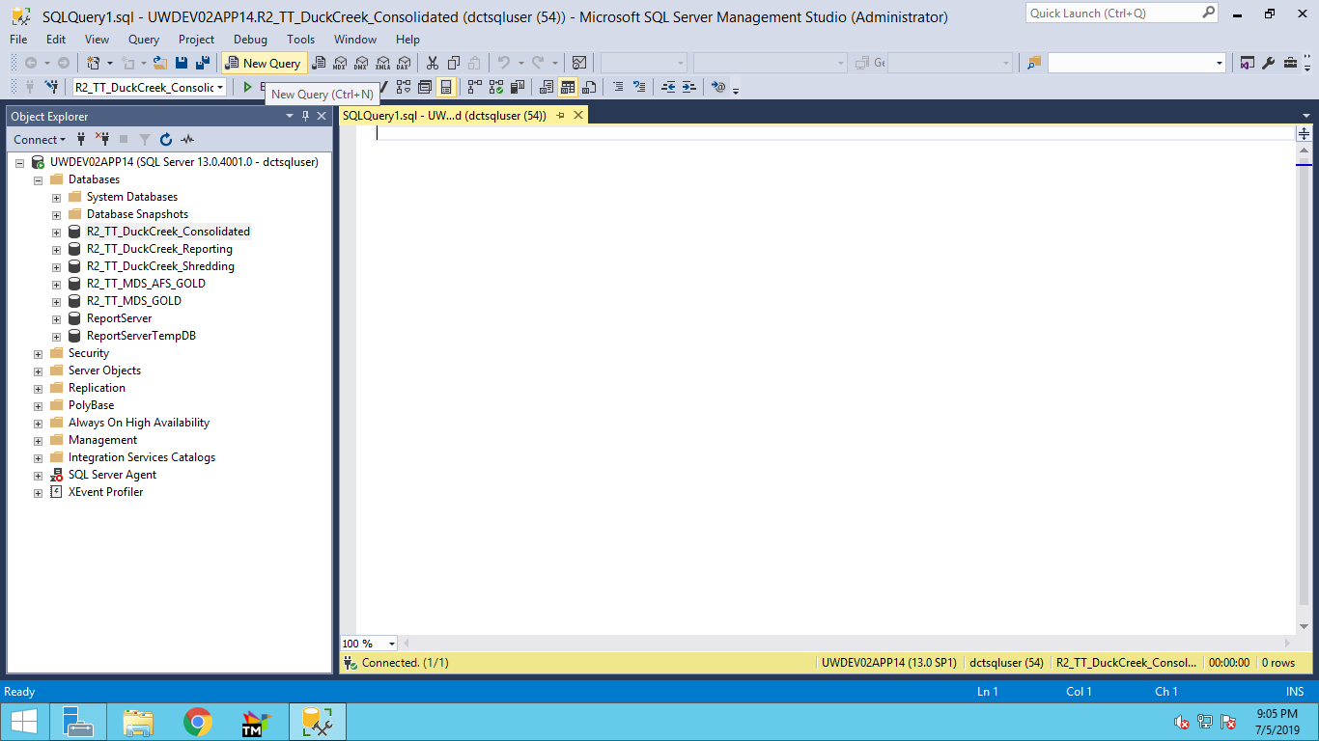

Select database R2_TT_DuckCreek_Consolidated

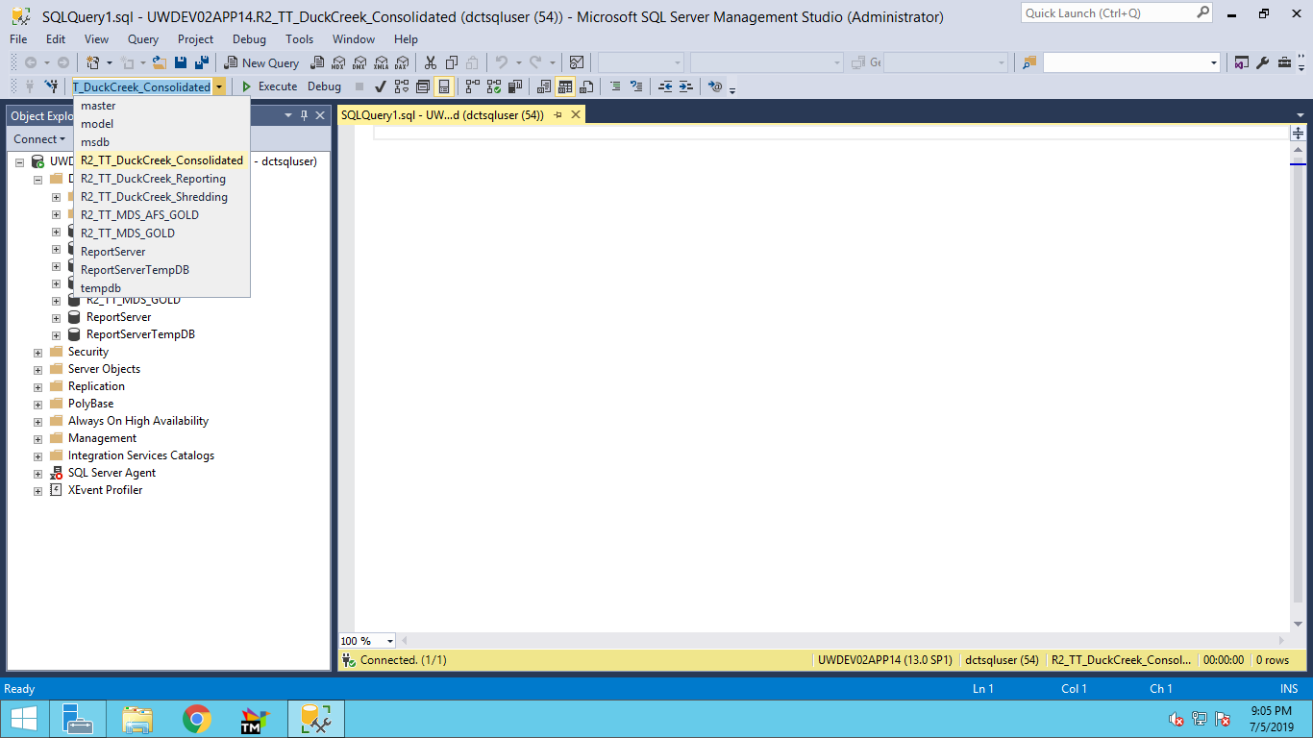

Run Query:

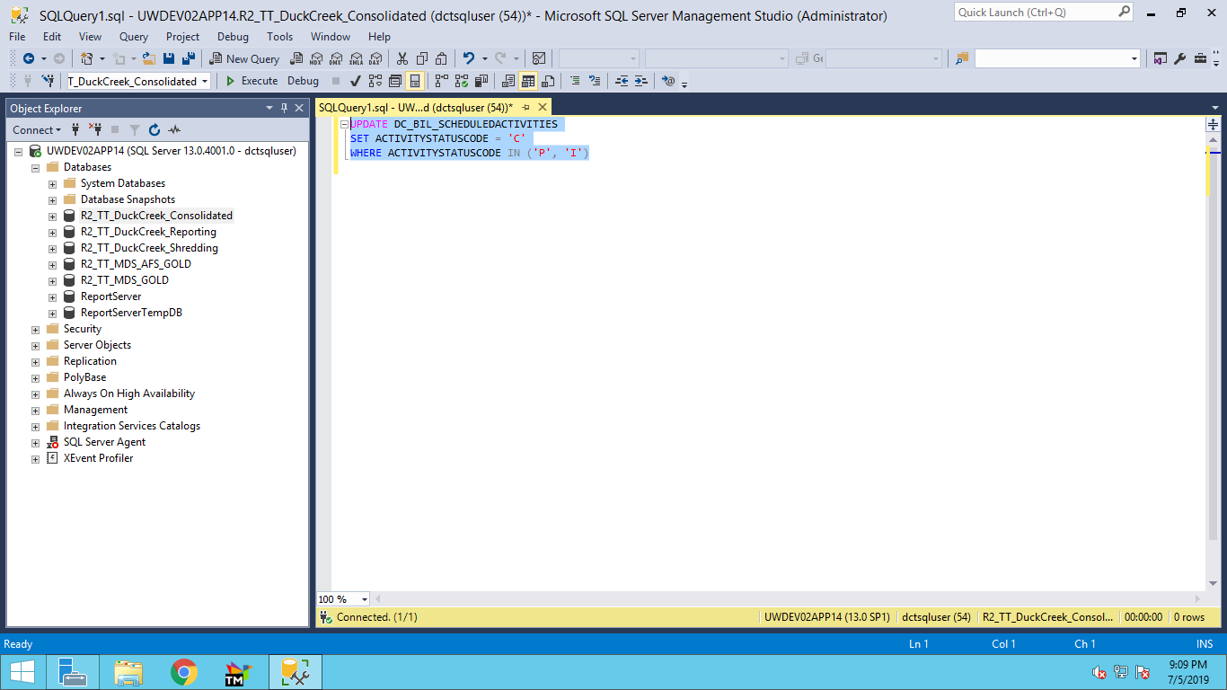

Click on Execute after selecting the query. Below Shown query is the performance query which should be run at the start of the day.

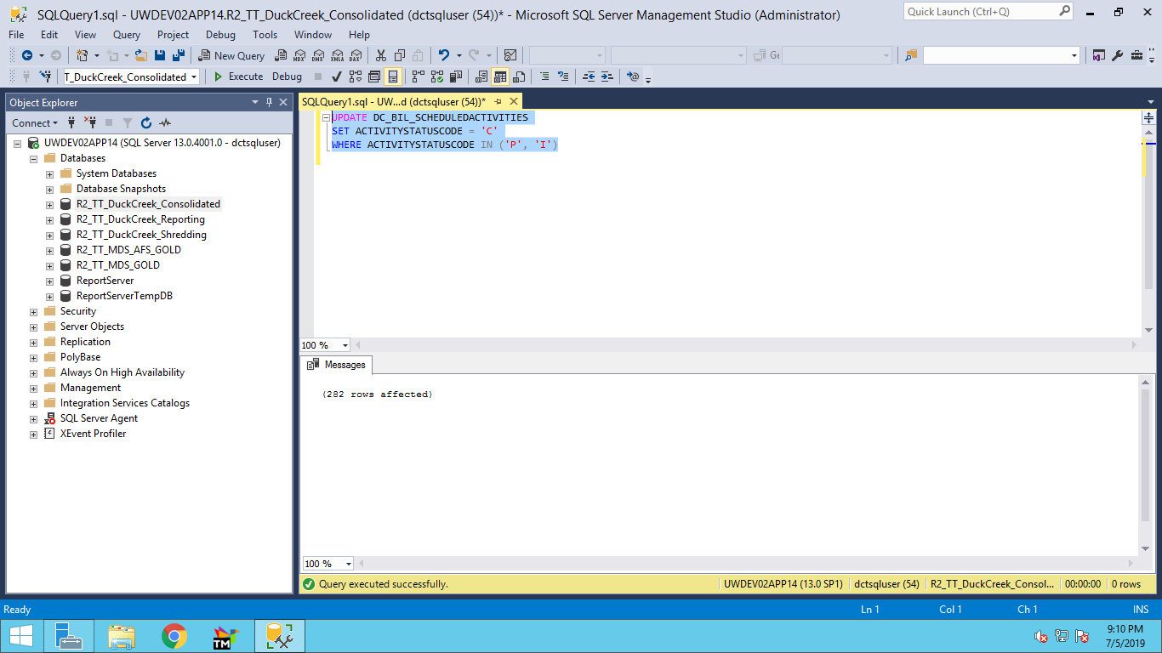

Query executed message should be displayed as given above.

To check if Any Activity is pending(P) or Interrupted(I) Run the query as shown :

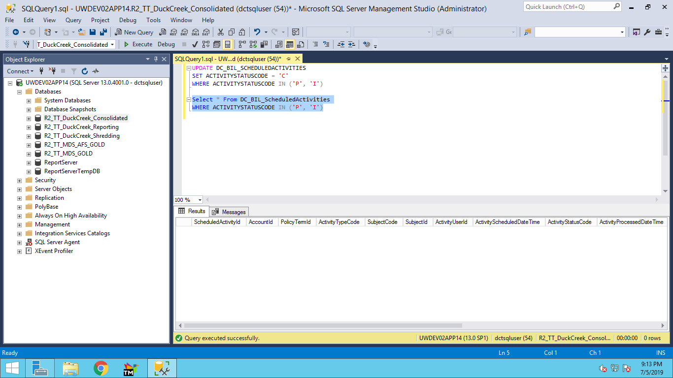

SQL queries:

Performace Query:

UPDATE DC_BIL_SCHEDULEDACTIVITIES

SET ACTIVITYSTATUSCODE = 'C'

WHERE ACTIVITYSTATUSCODE IN ('P', 'I')

SELECT * FROM DC_BIL_ScheduledActivities

WHERE ActivityStatusCode IN ('P')

Query to Check Scheduled Activites status for an account using account from Billing.

select * from DC_BIL_Account where AccountReference = '0000000000028774'

Not AccountId of the AccountReference

select * from DC_BIL_ScheduledActivities where AccountId = '23511'

To check Activities in P or I status:

select * from DC_BIL_ScheduledActivities where ActivityStatusCode IN('P','I')